RELATIONAL ALGEBRA

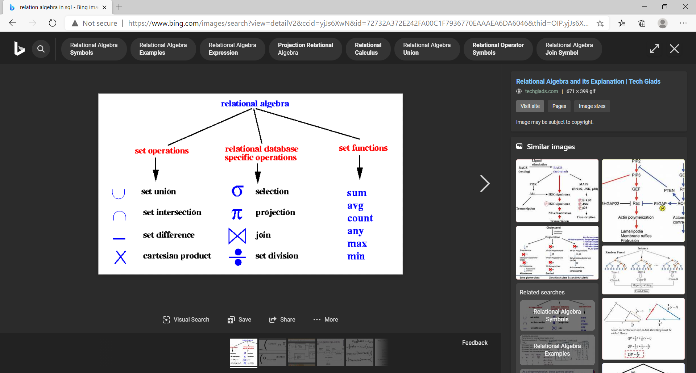

**SET OPERATIONS:**

NOTE: for union, intersect and minus (number, order of table and data type must be compulsory same or it’ll give error).

1)Union Operation (union and union all):

union by default remove the duplicate values.

In case you need the duplicate values as well use union all.

Table Union & Union All

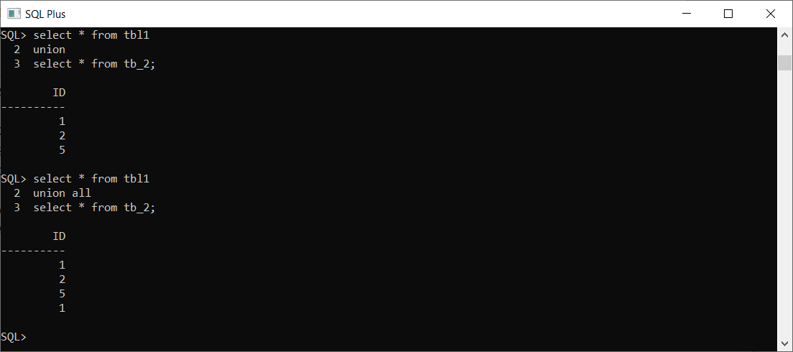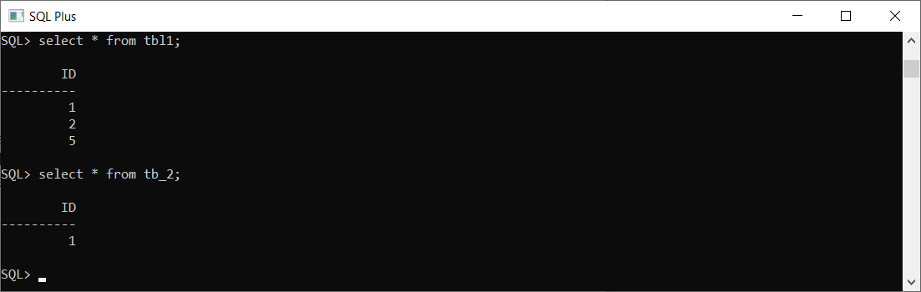

2)Intersection: (3) set difference /minus:

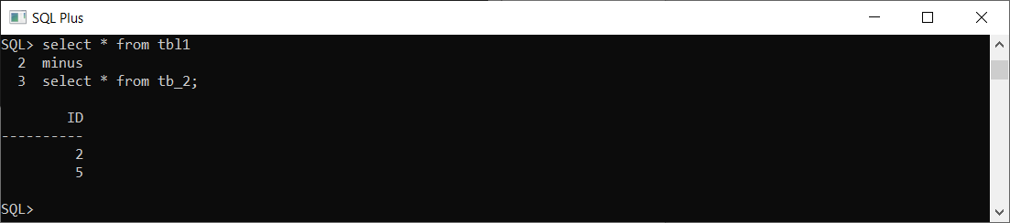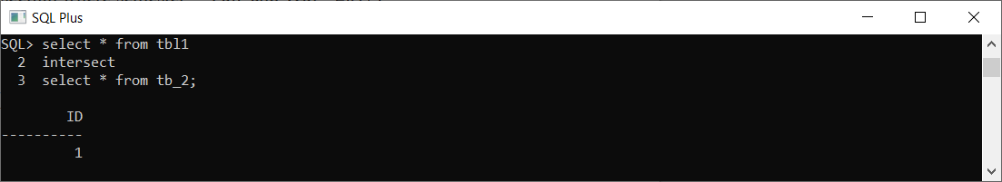

4)Cartesian product : a X b

SQL>select * from tbl1,tbl2;